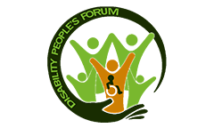

PURPOSE
Disability People’s Forum: The purpose of Disability
People’s Forum is to help every people in the society with
disabilities to enjoy quality and productive life in this
generation. We want disabled people to have equal rights
to education, employment, and cultural life, the right to
own and inherit property, not to be discriminated against in
marriage.

Subject: Introduction and Appreciation
Dear Dr. Muhammad Shabbir Awan,
I hope this email finds you well. My name is Musodi Erie and I am a proud member of the Disability People’s Forum Uganda. As an advocate for accessibility and inclusion, I deeply appreciate your significant contributions to the field of digital accessibility and internet governance.
Your expertise in international relations, policy formulation, and strategy development has had a positive impact on creating a more accessible and equitable online environment for persons with disabilities (PWDs). Your leadership as the former President of the ISOC Accessibility Special Interest Group (now the ISOC Standing Group on Accessibility) and your involvement in various global and regional initiatives demonstrate your commitment to making the internet equally trustable and inclusive for all.
I look forward to the opportunity to connect with you further and explore potential collaborations. Thank you for your tireless efforts in advancing accessibility and disability rights.
Warm regards,
Musodi Erie.
Disability People’s Forum Uganda

